Name: __________________________________
Homework Packet
for the week of July 14 - July 18

Hello everyone!

This homework packet is for the week. It is due on Friday, July 18th. You may hand it in early on Thursday.

Remember:
Do a page, or two pages, a day.
Show your work and your thinking.
Take your time writing so your handwriting is neat.

Reading:
- Make a prediction using the cover and blurb
- Write about what you know about the Olympics

Math:
- Addition word problem
- Subtraction word problem

Name: ____________________________ Date: ______________________

Write down at least 4 details you notice about the cover. (Think LAMB: looks, action, more (what you think) and background) Write what you predict will happen and WHY.
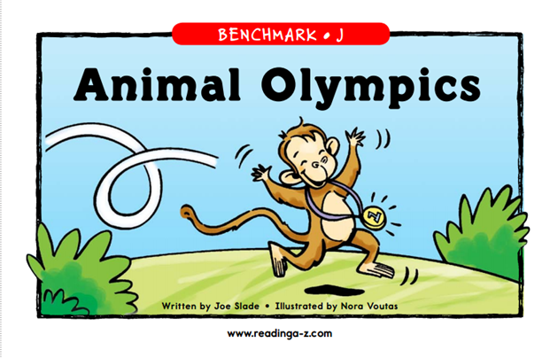
Bongo the monkey is excited to compete in the sports events, but after several last-place finishes, he's worried he won't win a gold medal. Find out if Bongo wins gold in this book about excelling at what you're good at.
I notice _________________________________________________________________________
________________________________________________________________________________________________________________________________________________________________________________________________________________________________________________________________________________________________________________________________________________________________________________________________________________
I predict that in the story __________________________________________________________
________________________________________________________________________________________________________________________________________________________________
because ________________________________________________________________________
________________________________________________________________________________________________________________________________________________________________
________________________________________________________________________________________________________________________________________________________________
Adult Signature: ____________________________
Name: ____________________________ Date: ______________________
The story is titled Animal Olympics.
Think about what you know about the Olympics. Write down what you know about the Olympics. Think about the Summer Olympics, Winter Olympics, athletes, countries, traditions, and different events (for example, swimming, skiing, gymnastics, ice skating).
________________________________________________________________________________________________________________________________________________________________
________________________________________________________________________________________________________________________________________________________________
________________________________________________________________________________________________________________________________________________________________
________________________________________________________________________________________________________________________________________________________________
Why do you think athletes compete (participate) in the Olympics?
________________________________________________________________________________________________________________________________________________________________
________________________________________________________________________________________________________________________________________________________________
________________________________________________________________________________Adult Signature: ____________________________
Name: ____________________________ Date: ______________________
Solve.
Show your thinking.
Write a sentence for your answer.

Ms. Lillian bought 6 green apples, 5 red apples and 4 yellow apples. How many apples did she buy?

Sentence: ______________________________________________________________________
_______________________________________________________________________________
Adult Signature: ____________________________
Name: ____________________________ Date: ______________________
Solve.
Show your thinking.
Write a sentence for your answer.

Ms. K made 15 bubble teas to sell at her bubble tea shop. She sold 9 bubble teas in the morning. How many more bubble teas does she have to sell?

Sentence: ______________________________________________________________________
_______________________________________________________________________________
Adult Signature: ____________________________

